Getting Started in Famili Vistas

**Steps to build your Family tree in Famili Vistas**

Fill up the registration form by clicking on the registration button in the right side of the Home page which opens a page with option to register using Phone # or email ID. Complete the authentication as per your choice of option, by entering your OTP received on phone or mail ID and agreeing to the Terms of usage and Privacy Policy.

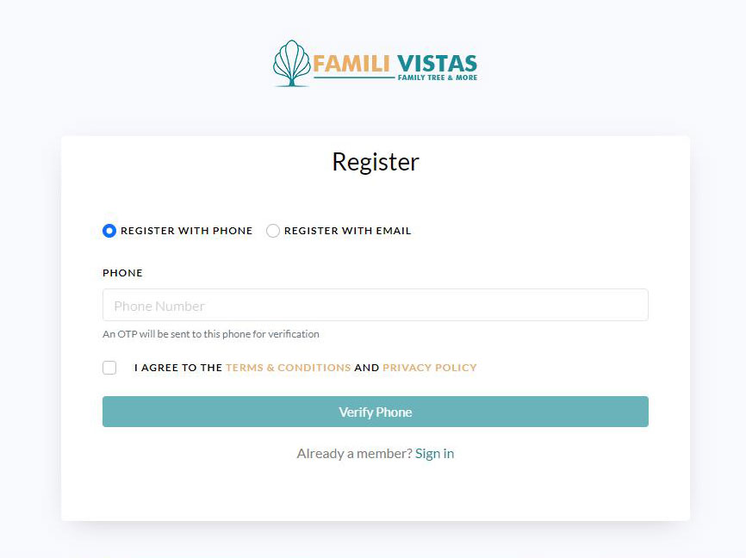

On completion of verification, the registration expands to allow entering your name, date of birth, gender, and few other optional details to complete the registration.

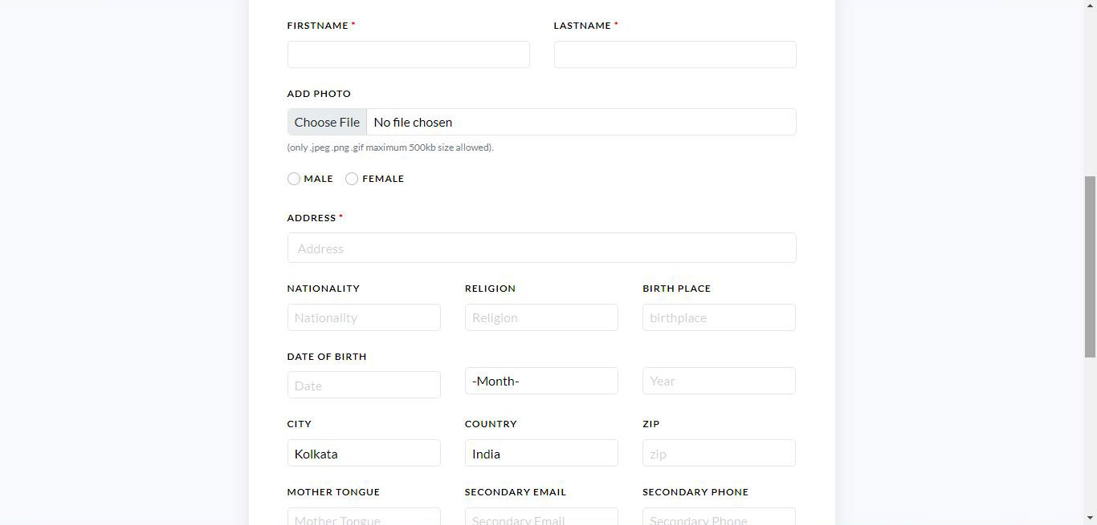

On completion of registration, it opens the Login page. You can also login later by clicking the login button on the right-hand top corner of the home page.

Click on the Login button and enter your login ID (which is your phone # or email ID entered during registration) and enter the OTP to verify the same.

It opens-up the plan page and allows you to select the type of subscription you wish to choose and complete the payment.

On payment, you are logged into your personal Famili Vistas page.

Now you can login using your User ID and OTP whenever you want by clicking on Login button on the right side of the home page which takes to your Famili Vistas personalized Family Tree home page. You can personalize it further by adding a photograph of your family house or any other picture of your liking. It also shows up your first family tree card with you as the creator. This starts your **Family tree**.

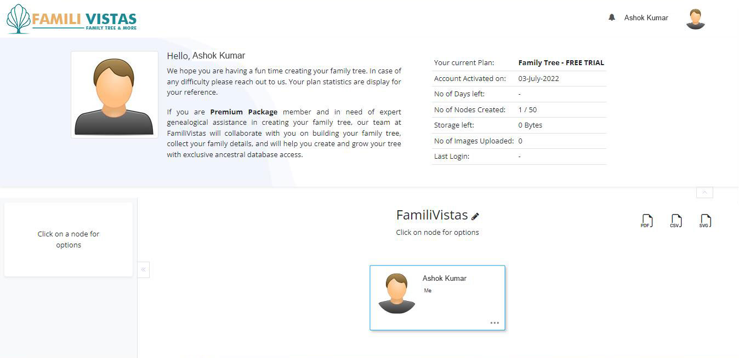

You will see your profile photo on the top left side of the screen. On clicking a node in your Family Tree you can add profile photo, add a family member, edit the member, delete the member, invite any family member to view and add their members, Edit profile photo, and much more.

You can add Biography of your Family in a dedicated space provided. You can also add significant events which provide a space to enter the event with date and photographs.

You can also add Links to related sites of your choice to provide more details of your family, Laurels and accolades comprising photographs (max 4-5 of size)

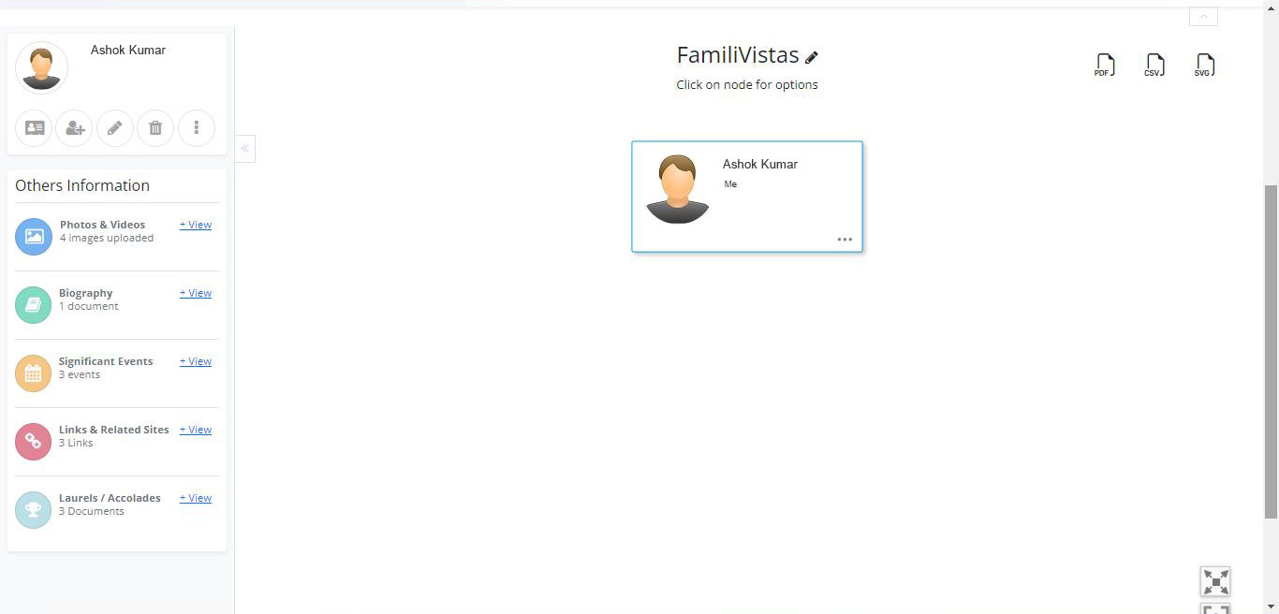

To Add Father or Add Mother, enter their information either by clicking on Add members icon on the top left on the left side panel or right click your photograph, add, and click Save.

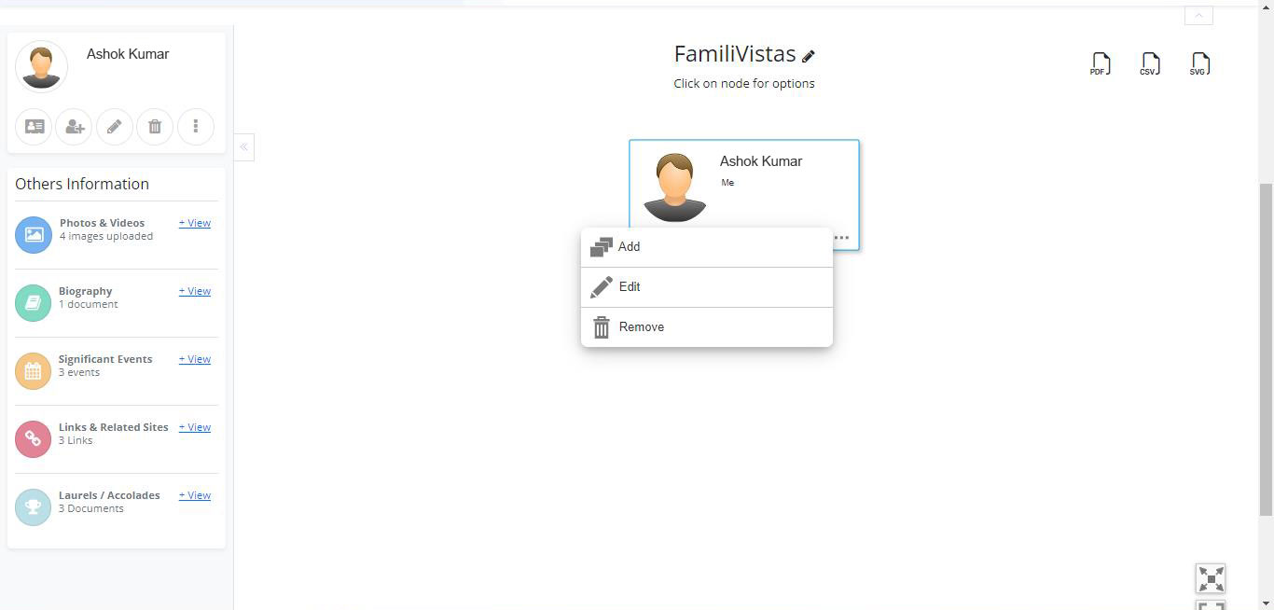

You are able to add children, by clicking on yourself or your spouse and select the child and enter the details.

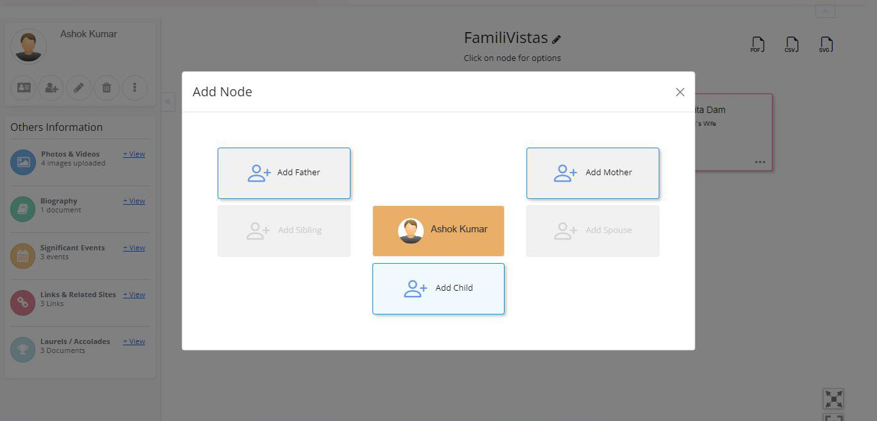

To add grandchildren, click on your child and add a child to them in the same manner and enter the details.

Once you save you may add more people or enter the name of your tree. Save the tree. Once your tree is created, you can access it whenever you want.

Now you can preview your Tree, download your tree; print your tree in pdf, csv or svg file format. You can also share your tree by clicking on Share icon.

**Entering information in a tree**

**Names**: Enter full names wherever possible. Use maiden names for women (leaving off their married names; these are implied by any spouses they have in the tree).

**Dates**: List dates in dd mm yyyy format (for example: 01 Jan 2022). If you’re unsure of the day or year, fill up whatever, you are sure. For Example -you may just enter the Year or month and Year only.

**Correcting mistakes**

You can always edit to change name, gender, living status, or birth or death information you entered by clicking edit on the icon in the left of the screen below your profile image and click save.

**Enjoy your Family Journey with Famili Vistas!**