**Self Help Guide**

**How to draw a family tree chart**

A family tree can be as simple or as complicated as you want it to be.

A simple genealogy chart may include you, your parents, your grandparents, and your great-grandparents. A complicated family tree chart may include you, your parents, your siblings, aunts and uncles, cousins, and so on.

How far you go and who you include is up to you.

**Basic Understanding before starting your Tree**

**1. Chalk out a Plan**

Before you jump in and start drawing your family tree, you may want to do a little planning. For example, you might ask yourself:

* How far do you want to go back?
* Is there somebody in your family who already has this information to give you a starting point?
* What type of information do you want to include on each leaf (births, marriages, deaths)?
* Do you want to add pictures of your ancestors to each leaf? Where can you find these pictures?

You also may want to determine in which direction you will draw the tree. In nature, trees grow from the ground to the sky, but on paper or the computer screen, family trees can develop from the bottom up, the top down, or horizontally. It could be a good idea to look at some examples of family trees to help you decide how your tree will be drawn.

There is not a single family tree definition that dictates what has to be included or what the family tree should look like. But note that if you simply want to chart relationships without digging too deeply, you may draw a simple family tree and represent relationships to help you visualize your lineage.

Diagram Template (Click on image to modify online)

**2. Gather information about your family**

Write down what you know, ask family members to fill in the gaps, and find pictures and documents. Enquire with your elders, scan through your family albums and try other online genealogy sources to search for census records, news stories, land deeds, and other documents that can verify your ancestry.

Remember that you can only go back so far because of the limited availability of reliable records. It is very hard to find accurate records older than a few hundred years because many records have been destroyed in fires, floods, acts of war, and simple negligence. Some areas of the world were better at keeping and preserving records than others, so how far you can go back will depend on how much of your family records you are able to trace. Most family tree outlines trace ancestry back three or four generations because of the limited information.

**3. Draft a family tree outline**

Compile all of the information you have and create an outline. Start drawing from yourself to your ancestors, or start with the oldest ancestor you know about and trace forward to you.[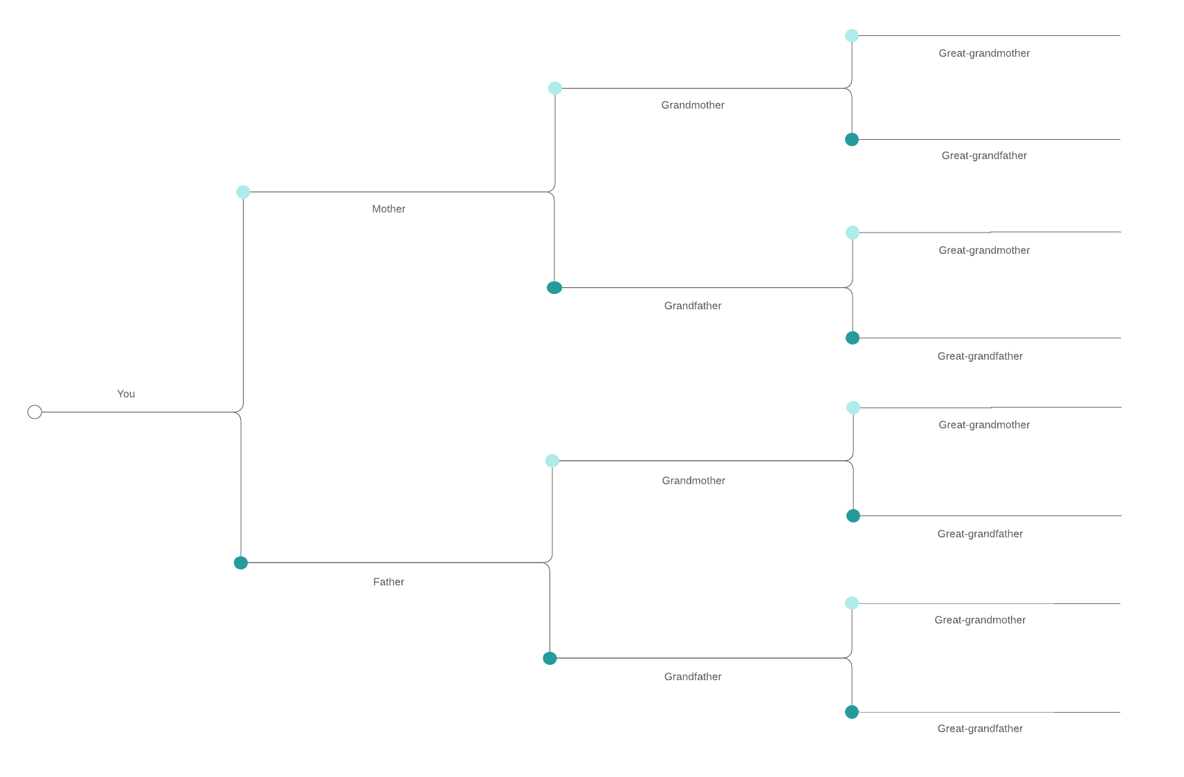](https://www.lucidchart.com/documents/editNewOrRegister/f97d2fc9-73a1-49a1-a3d2-edf26919b02a?anonId=0.4cdc6c1a17ed99f2601&sessionDate=2022-02-08T13:56:32.899Z&sessionId=0.3604d9c217ed99f2602)Family Tree - Basic Genealogy (Click on image to modify online)[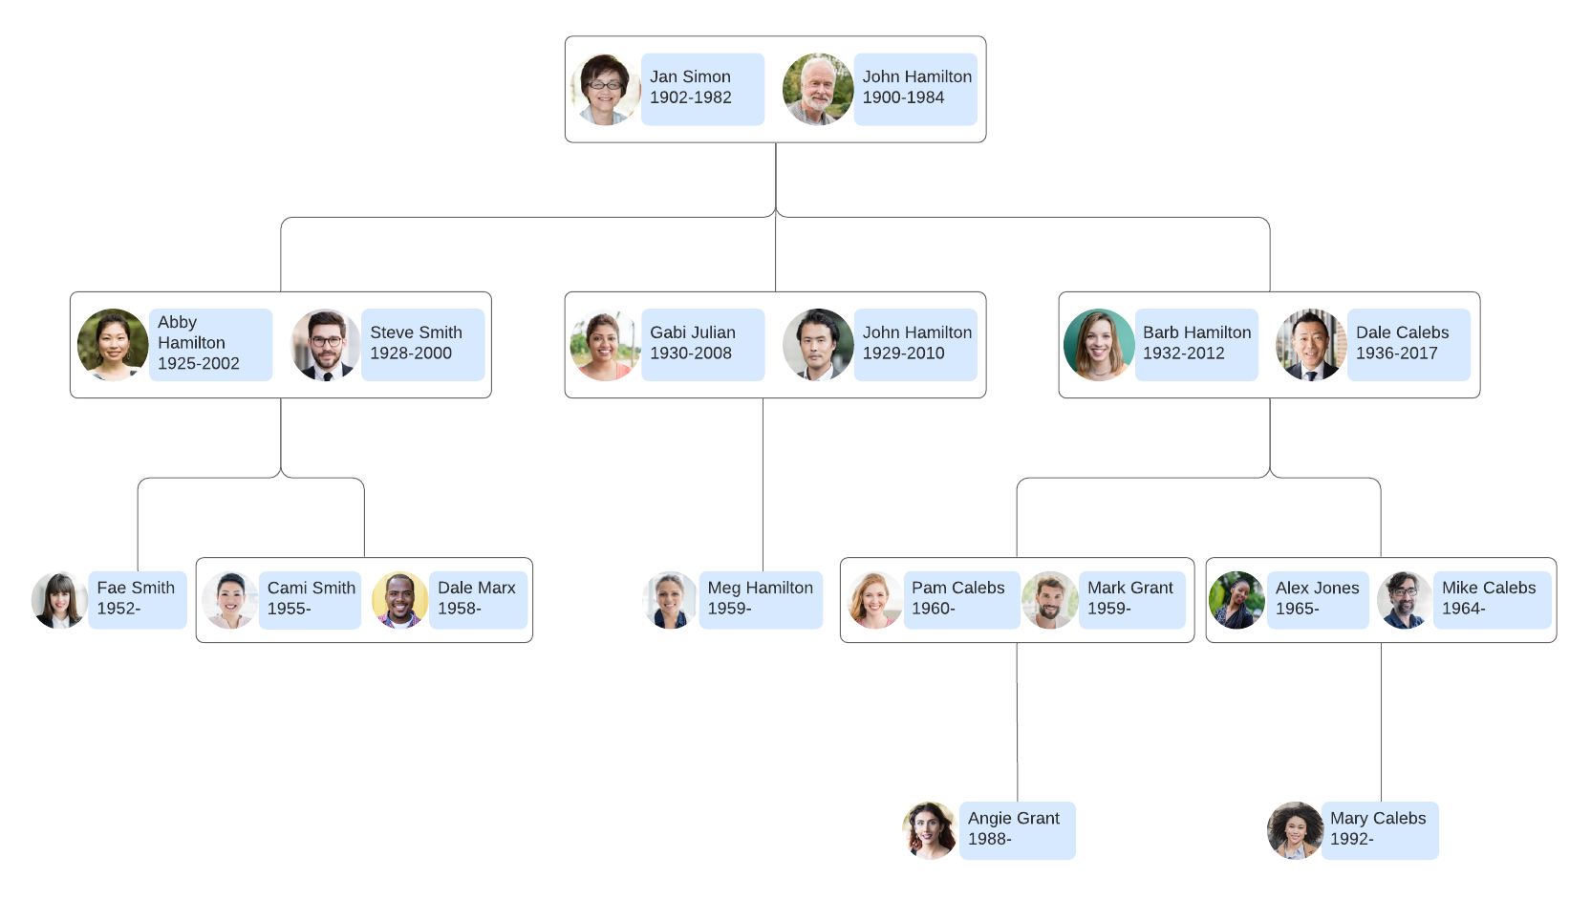](https://www.lucidchart.com/documents/editNewOrRegister/ec6c1472-0edd-4c08-9d12-de4d5e57656a?anonId=0.4cdc6c1a17ed99f2601&sessionDate=2022-02-08T13:56:32.899Z&sessionId=0.3604d9c217ed99f2602)Genealogy Chart Example (Click on image to modify online)

[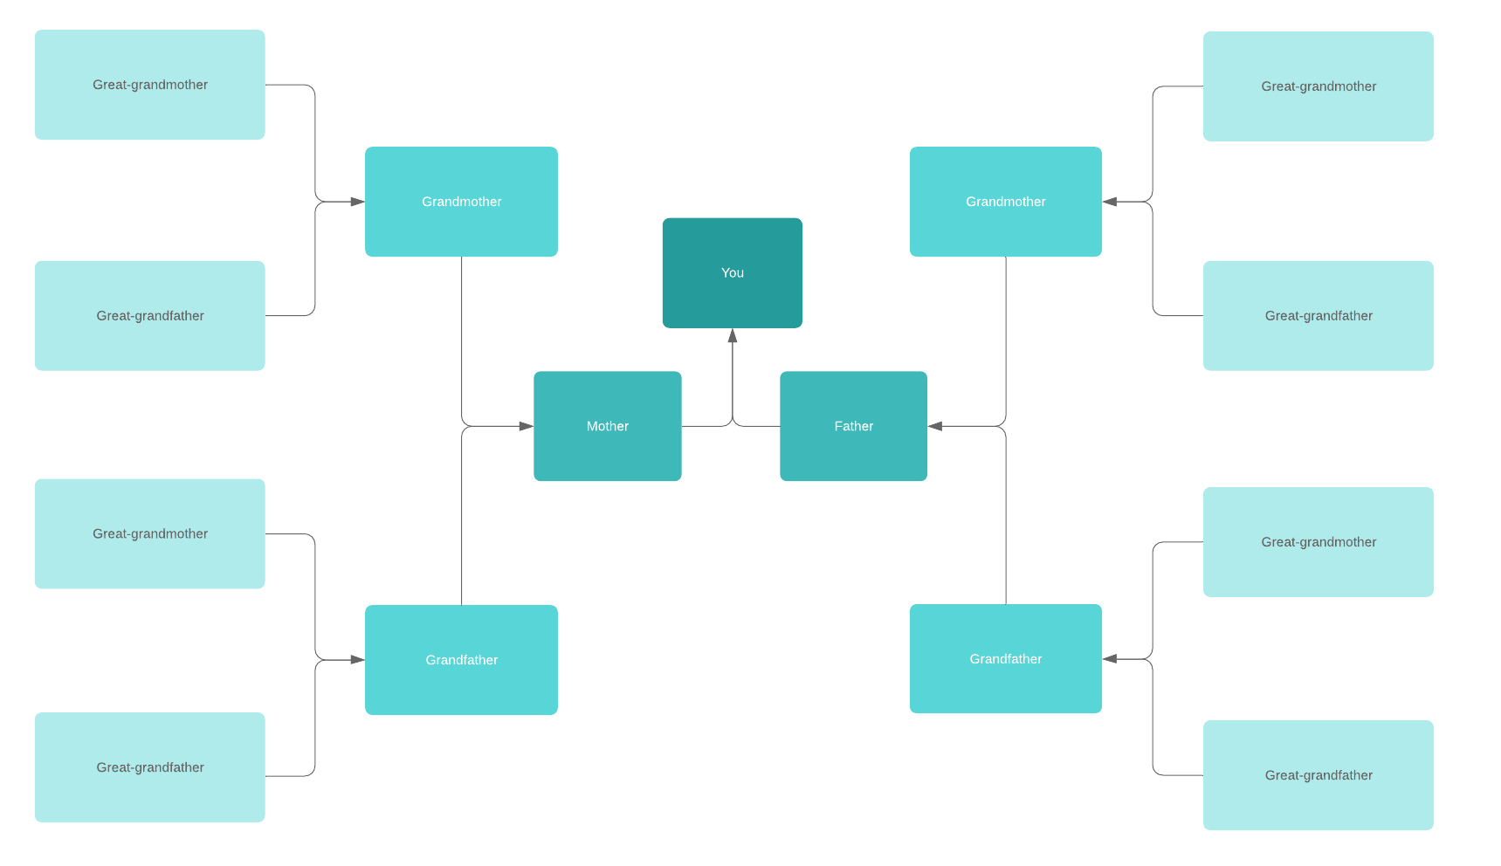](https://www.lucidchart.com/documents/editNewOrRegister/70fa6058-1d42-466d-9a09-348e2a241753?anonId=0.4cdc6c1a17ed99f2601&sessionDate=2022-02-08T13:56:32.899Z&sessionId=0.3604d9c217ed99f2602)Family Tree - Bowtie Genealogy (Click on image to modify online)

**4. How to add information to each leaf**

Each family member will be represented by a shape connected by lines to represent relationships. Typically a box or rectangle is used to represent your relatives, but you can use any shape that you want to use. Each shape is a leaf on the tree. The shape you decide to use as leaves should be consistent and sized to include the information that you plan to put on your family tree chart.

Place pictures, important event dates, and any other information you want to include in your leaf. As you put together this information, we would recommend a few additional guidelines:

**5. Keep it simple**

If you want your family tree diagram to be useful to other members of your family, keep it simple so the information can be easily scanned and digested. Try to have each level of the tree represent a single generation so it is easy to trace relationships.

**6. Don’t air your family’s dirty laundry**

Who is going to be looking at this family tree diagram? There may be some family secrets that are not known to all living family members, so try to be sensitive about adding information that may not be too welcome to some of your relatives.

**Getting Started**

Steps to start a tree in Famili Vistas

From any page on Famili Vistas, click the **Trees** tab and select **Start a New Tree** (if this is your first tree) or **Create & Manage Trees** > **Create a new tree**.

1. Click **Add Yourself** or **Add home person**.
2. Enter information and click **Save** or **Continue**.
3. Click **Add Father** or **Add Mother**, enter their information, and click **Save**. If you're adopted or don't know the names of your biological parents, see [this article for help](https://support.ancestry.com/s/article/Finding-Adoption-and-Orphanage-Records).
4. Follow the prompt to add more people or to name the tree. Save the tree. Once your tree is created, you can access it from the Trees tab.
5. To add children, click on yourself and select **Tools** tools > **Add relative** > **Child**.
6. To add grandchildren, click on your child and add a child to them (step 6).

**Entering information in a tree**

* **Names**: Enter full names when possible. Use maiden names for women (leaving off their married names; these are implied by any spouses they have in the tree). For more information about maiden names, see [When to Use Maiden Names](https://support.ancestry.com/s/article/When-to-Use-Maiden-Names).
* **Dates**: List dates in dd mmm yyyy format (for example: 25 Dec 1928). If you’re unsure of the day or year, use the words *before*, *after,* or *about* before the date. You can also use *ca.* (circa) to indicate an estimate.
* **Places**: Record as much information as possible about where an event happened. List the smallest level first and the largest level last (for example: “Venice, Veneto, Italy”). When you begin entering a location, select it from the drop-down menu, if it appears. If it's not there, put a comma and a space between the location levels (like "City, State, Country") and include the country. Include all known levels of a place when not all levels are known.

**Correcting mistakes**

For help changing relationships in your tree, see [Fixing Relationships in Trees](https://support.ancestry.com/s/article/Fixing-Relationships-in-Trees). To merge duplicate people, see [Merging Duplicate People](https://support.ancestry.com/s/article/Merging-Duplicate-People).

To change name, gender, living status, or birth or death information you entered for someone in your tree:

1. Click on someone in your tree whose information has an error.
2. In the card that appears, click **Quick edit**.
3. Change the information and click **Save**.

**Adding a relative to someone in your tree**

1. In your tree, click on a close relative of the person you're adding.
2. In the card that appears, click Tools > **Add relative**.
3. Select the type of relationship you're adding. If you're adding a sibling and don't see "Sibling" listed, you need to add at least one parent first; siblings can only be attached to each other in a tree through their parents.
4. Enter the person's information and click **Save**.

**Adding more than two parents**

If someone in your tree has two parents in the tree, you'll need to add them in a different way than the steps above.

1. Click on the person whose parent you're adding.
2. In the card that appears, click **Profile**.
3. On their profile page, click **Edit** in the top-right corner and select **Edit relationships**.
4. Click **Add alternate mother** or **Add alternate father**.
5. Click **Add new person**.
6. Enter information about the parent and click **Save**.
7. On the card you now see, make sure the parents that are listed have the right type of relationship selected. To change a relationship, click the drop-down menu that displays the relationship Biological and select an option.
8. Two parents will primarily be displayed when you look at the tree. Mark the parents you want to be displayed by clicking Make preferred.

**Adding specific relationships**

**Siblings**: You have to have at least one of the siblings' shared parents in your tree before you can add a sibling. Since siblings are connected to each other through their parents (half siblings, through one parent, and full siblings, through two parents), siblings can only be attached to each other in a tree through their parents. If you don’t know the name of a parent, add a parent as “Unknown,” then add a child to the unknown parent. Once a parent is in the tree, click on the shared parent from your tree. In the card that appears, click Tools > Add relative > Child. Add the sibling's information and click Save. For more information, see [Siblings, Half Siblings, and Stepsiblings in Family Trees](https://support.ancestry.com/s/article/Siblings-Half-Siblings-and-Stepsiblings-in-Family-Trees).

**Stepfamily**: Add a stepparent by attaching them as a spouse to the parent, then unchecking "Include these individuals as children of this spouse." Add a stepsibling by adding a child to the stepparent, and in the Parents section, selecting the option that includes "Unknown Mother / Father." For more information, see [Siblings, Half Siblings, and Stepsiblings in Family Trees](https://support.ancestry.com/s/article/Siblings-Half-Siblings-and-Stepsiblings-in-Family-Trees).

**Adopted family**: [Add an adopted family member](https://support.ancestry.com/s/article/Listing-Adopted-Family-in-a-Tree?language=en_US&r=57&ui-knowledge-components-aura-actions.KnowledgeArticleVersionCreateDraftFromOnlineAction.createDraftFromOnlineArticle=1) the same way you’d add a biological family member. Then, go to the profile page of the adopted person and click Edit > Edit Relationships > Biological and change it to "Adopted."

**Unmarried parents**: Add the parents the way you’d add anyone else. Then, go to the profile page of one of the parents and click Edit > Edit Relationships > Spouse and change it to "Partner," "Single," "Friend," "Other," or "Unknown."

**Unrelated person**: Add the unrelated person as any type of family member to anyone in your tree. You're going to disconnect the relationship, but the only way to add someone at first is to add them as a family member. For example, you could click on your mother in your tree, click Tools > Add relative, and add the new person as any type of relative to your mother. Once they're added, go to the new person's profile page and click Edit > Edit relationships. On the relationship on that page, click the **X** to disconnect the relationship. This will leave the unrelated person in your tree, but they won't be connected to anyone else. To find them in the tree, you'll need to enter their name in the [Tree Search](https://support.ancestry.com/s/article/Finding-People-in-Your-Tree) menu.

**Adding people from a record**

Some records include information about multiple people. For example, census records often include the names and ages of married adults and any children who live with them. When you add a record to your tree that mentions multiple people, you'll have the option to add anyone from the record to your tree.

1. To save a record you've found, click **Save** > **Save this record to [name]**.
2. Facts from the record you're saving will be on the left, and facts that are already in your tree will be on the right. Check the boxes for any facts you'd like to add or edit.
3. Scroll down to see others in the record that you can save to your tree and check the boxes next to people you'd like to add.
4. Click **Save to your tree**.

**Copying someone from another tree**

You can add people from other people's public trees to your tree (or copy people from one of your trees to another). Sources and media aren't included, but they can be added once someone is in your tree. Only one person can be copied at a time, and it's not possible to copy living people.

To learn how to copy people from a tree, see [Copying People from Trees](https://support.ancestry.com/s/article/Copying-People-from-Trees).

**Adding facts and events**

1. Go to the profile page of a person in your tree.
2. From the Facts tab of their profile page, in the **Facts** column, click **Add**.
3. In the menu that appears, click **Select an event type** and select a type of fact or event. To create a type that’s not listed, click **Custom Event**.
4. Enter information and click **Add**. If you’re adding a duplicate event (like a second birthdate), you’ll see the option to check a box that says **Preferred**. If you don’t make it preferred, the event that was entered first is the one that will be listed on your family tree, though both events will remain listed in the person’s facts.

#### Your profile

Information you enter in to your profile can be used to help other Ancestry members find you, if you list your interests. From any page on Ancestry, click your name or username in the top-right corner and select **Your Profile**.

 Famili Vistas Genealogists

Famili Vistas Genealogists have spent years helping clients tackle difficult family history problems, find family members, and trace their family trees. Using online and offline resources and experts around the world, our professional genealogists have the experience to help you reach your family history goals. Request an estimate by emailing us to support@familivistas.com.

#### Memberships

After building your tree as much as you can with the information you know, the next step is to purchase a membership and search for records. Without a membership, you have limited access to a number of records. But with a membership, you gain access to many more records through our expert genealogical assistance.

**Gathering information**

The first step in building a family tree is gathering the records and information you already have. These records tend to be most useful:

* Family group sheets, pedigree charts, and books of remembrance
* Family Bibles
* Journals, diaries, and letters
* Photographs
* Obituaries and newspaper clippings
* Birth, marriage, and death certificates

If you’d like to organize information in a paper chart before entering it online, download our free family group sheet or pedigree chart. Our many [blank charts](http://www.ancestry.com/cs/charts-and-forms) are available for free.

Interviewing an older biological relative can help you gather information about your ancestors. Be sure to take notes..

**Sharing your tree**

It’s easy to [share your tree](https://support.ancestry.com/s/article/Sharing-a-Family-Tree?language=en_US&r=114&ui-knowledge-components-aura-actions.KnowledgeArticleVersionCreateDraftFromOnlineAction.createDraftFromOnlineArticle=1) with friends or family. From any page on Ancestry, click the **Trees** tab and select a tree. From the tree, click **Share** in the top-right corner**.**

**Having a tree built for you**

If you'd rather hire a professional genealogist to build a tree for you, see [Hiring a Genealogist](https://support.ancestry.com/s/article/Hiring-a-Genealogist?language=en_US&r=114&ui-knowledge-components-aura-actions.KnowledgeArticleVersionCreateDraftFromOnlineAction.createDraftFromOnlineArticle=1).

**Distribute your family tree diagram**

This is the fun part—once you have finished your genealogy chart or family tree diagram, share it with your family members and give them a chance to reflect on their genealogy or learn new family stories. You can also invite them to provide additional information.

If you have created your family tree diagram online, click “Share” to give family members access to collaborate on the visual with you or export your family tree to a number of file formats.

**Discover your family history**

It is easy to make a free family tree chart using Famili Vistas. No matter what time zone your family members reside in, everybody with the permission to share and edit the document can open it, add notes, and modify or make corrections at the same time. It’s a good way to bring your family closer without being in the same physical location.

Sign up for a nominal fee and start tracking your family history visually.

**What are you waiting for!**

[Sign up free](https://lucid.app/pricing/lucidchart?anonId=0.4cdc6c1a17ed99f2601&sessionDate=2022-02-08T13%3A56%3A32.899Z&sessionId=0.3604d9c217ed99f2602)