Self Help Guide

**How to draw a family tree chart**

A family tree can be as simple or as complicated as you want it to be.

A simple genealogy chart may include you, your parents, your grandparents, and your great-grandparents. A complicated family tree chart may include you, your parents, your siblings, aunts and uncles, cousins, and so on.

How far you go and who you include is up to you.

**Basic Understanding before starting your Tree**

**1. Chalk out a Plan**

Before you jump in and start drawing your family tree, you may want to do a little planning. For example, you might ask yourself:

* How far do you want to go back?
* Is there somebody in your family who already has this information to give you a starting point?
* What type of information do you want to include on each leaf (births, marriages, deaths)?
* Do you want to add pictures of your ancestors to each leaf? Where can you find these pictures?

You also may want to determine in which direction you will draw the tree. In nature, trees grow from the ground to the sky, but on paper or the computer screen, family trees can develop from the bottom up, the top down, or horizontally. It could be a good idea to look at some examples of family trees to help you decide how your tree will be drawn.

There is not a single family tree definition that dictates what has to be included or what the family tree should look like. But note that if you simply want to chart relationships without digging too deeply, you may draw a simple family tree and represent relationships to help you visualize your lineage.

**2. Gather information about your family**

Write down what you know, ask family members to fill in the gaps, and find pictures and documents. Enquire with your elders, scan through your family albums and try other online genealogy sources to search for census records, news stories, land deeds, and other documents that can verify your ancestry.

Remember that you can only go back so far because of the limited availability of reliable records. It is very hard to find accurate records older than a few hundred years because many records have been destroyed in fires, floods, acts of war, and simple negligence. Some areas of the world were better at keeping and preserving records than others, so how far you can go back will depend on how much of your family records you are able to trace. Most family tree outlines trace ancestry back three or four generations because of the limited information.

**3. Draft a family tree outline**

Compile all of the information you have and create an outline. Start drawing from yourself to your ancestors, or start with the oldest ancestor you know about and trace forward to you.[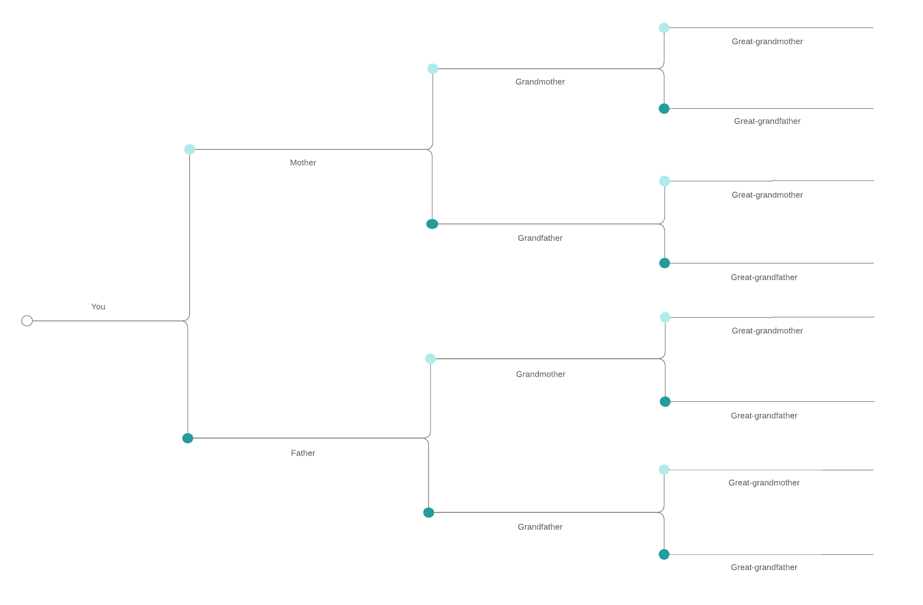](https://www.lucidchart.com/documents/editNewOrRegister/f97d2fc9-73a1-49a1-a3d2-edf26919b02a?anonId=0.4cdc6c1a17ed99f2601&sessionDate=2022-02-08T13:56:32.899Z&sessionId=0.3604d9c217ed99f2602)

Family Tree - Basic Genealogy [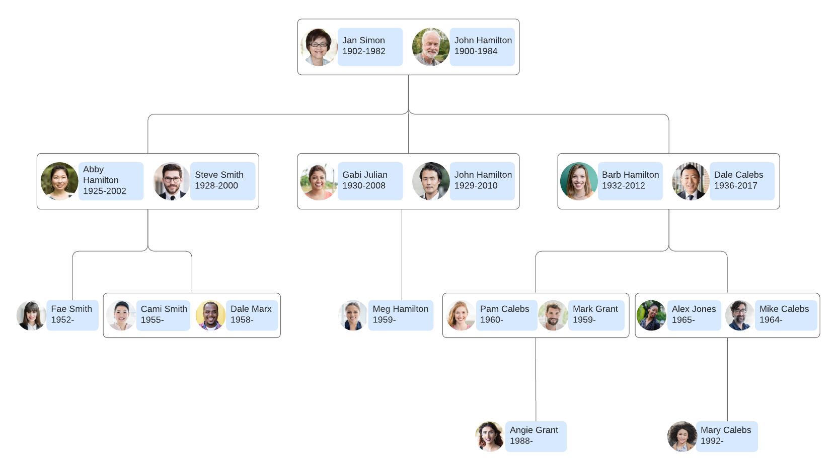](https://www.lucidchart.com/documents/editNewOrRegister/ec6c1472-0edd-4c08-9d12-de4d5e57656a?anonId=0.4cdc6c1a17ed99f2601&sessionDate=2022-02-08T13:56:32.899Z&sessionId=0.3604d9c217ed99f2602)Genealogy Chart Example

[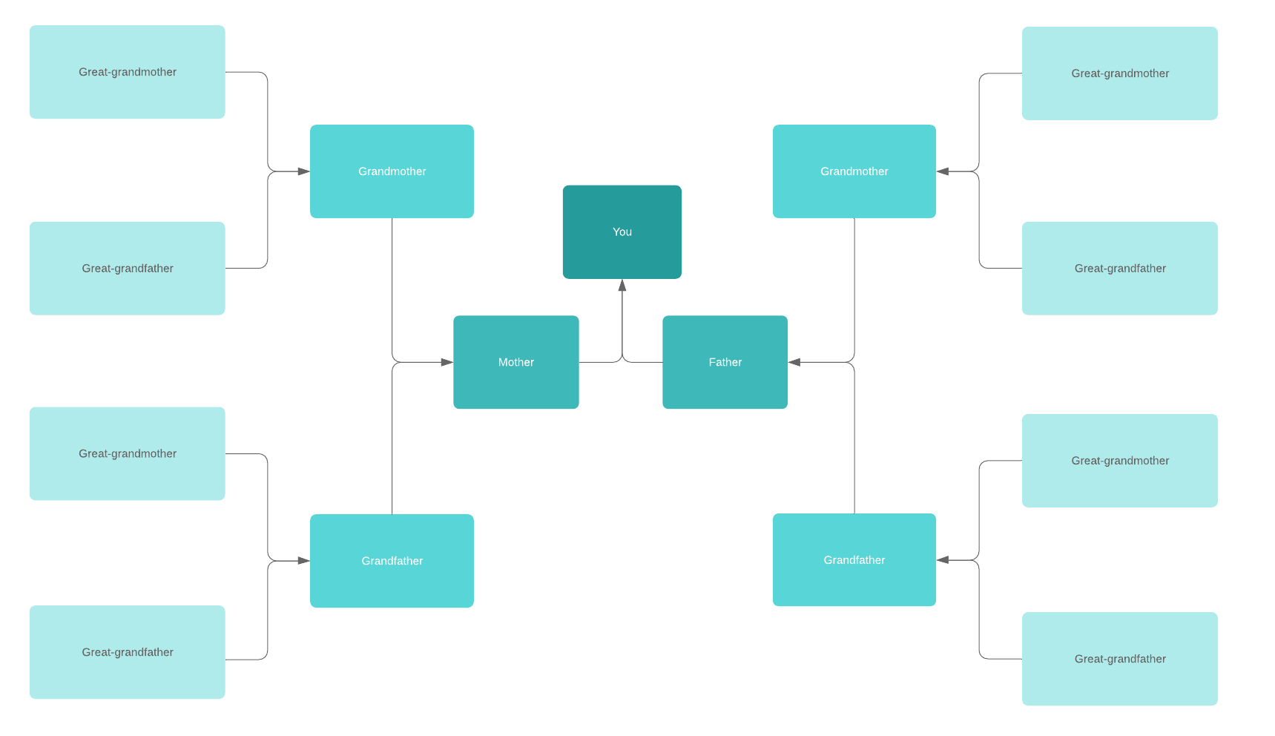](https://www.lucidchart.com/documents/editNewOrRegister/70fa6058-1d42-466d-9a09-348e2a241753?anonId=0.4cdc6c1a17ed99f2601&sessionDate=2022-02-08T13:56:32.899Z&sessionId=0.3604d9c217ed99f2602)

**4. How to add information to each leaf**

Each family member will be represented by a shape connected by lines to represent relationships. Typically a box or rectangle is used to represent your relatives, but you can use any shape that you want to use. Each shape is a leaf on the tree. The shape you decide to use as leaves should be consistent and sized to include the information that you plan to put on your family tree chart.

Place pictures, important event dates, and any other information you want to include in your leaf. As you put together this information, we would recommend a few additional guidelines:

**5. Keep it simple**

If you want your family tree diagram to be useful to other members of your family, keep it simple so the information can be easily scanned and digested. Try to have each level of the tree represent a single generation so it is easy to trace relationships.

**6. Don’t air your family’s dirty laundry**

Who is going to be looking at this family tree diagram? There may be some family secrets that are not known to all living family members, so try to be sensitive about adding information that may not be too welcome to some of your relatives.

**Getting Started**

For finding out the steps to start a tree in Famili Vistas, refer the document on “Getting Started in Famili Vistas”.

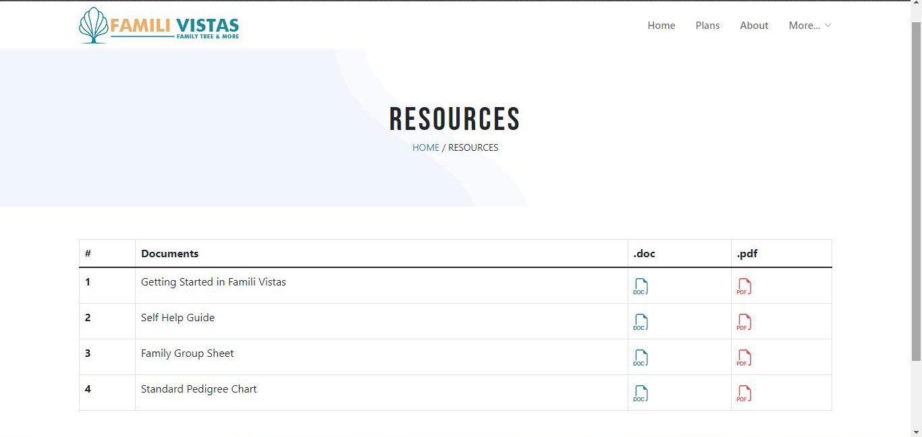

**Having a tree built for you**

If you'd rather hire a professional genealogist to build a tree for you.For hiring a genealogist, contact support@familivistas.com.

**Distribute your family tree diagram**

This is the fun part—once you have finished your genealogy chart or family tree diagram, share it with your family members and give them a chance to reflect on their genealogy or learn new family stories. You can also invite them to provide additional information.

If you have created your family tree diagram online, click “Share” to give family members access to collaborate on the visual with you or export your family tree to a number of file formats.

**Discover your family history**

It is easy to make a free family tree chart using Famili Vistas. No matter what time zone your family members reside in, everybody with the permission to share and edit the document can open it, add notes, and modify or make corrections at the same time. It’s a good way to bring your family closer without being in the same physical location.

Sign up for a nominal fee and start tracking your family history visually.

**What are you waiting for!**

[Sign up free](https://lucid.app/pricing/lucidchart?anonId=0.4cdc6c1a17ed99f2601&sessionDate=2022-02-08T13%3A56%3A32.899Z&sessionId=0.3604d9c217ed99f2602)